Contents

1 Setup Session 2

2 Folder Details 4

3 Setup Python Code – Not Used 5

4 Setup Node code 6

5 Setup Angular code 9

6 Linux Commands 12

# Setup Session

Click on Session

Click on SSH.

Enter Remote host – 140.238.166.54

Enter Username - opc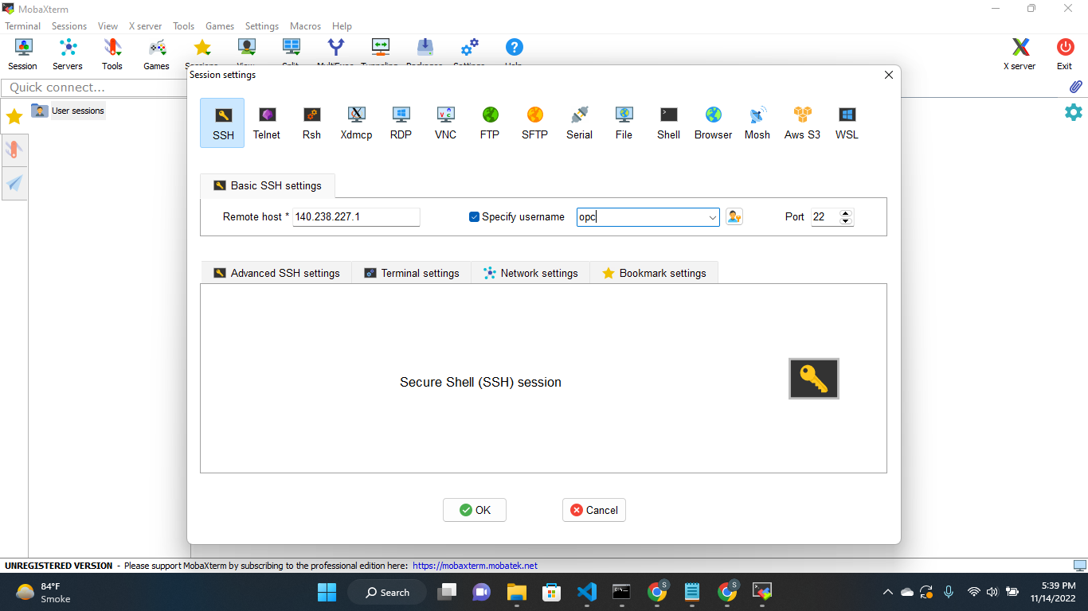

Click on Advanced SSH settings. Browse private key.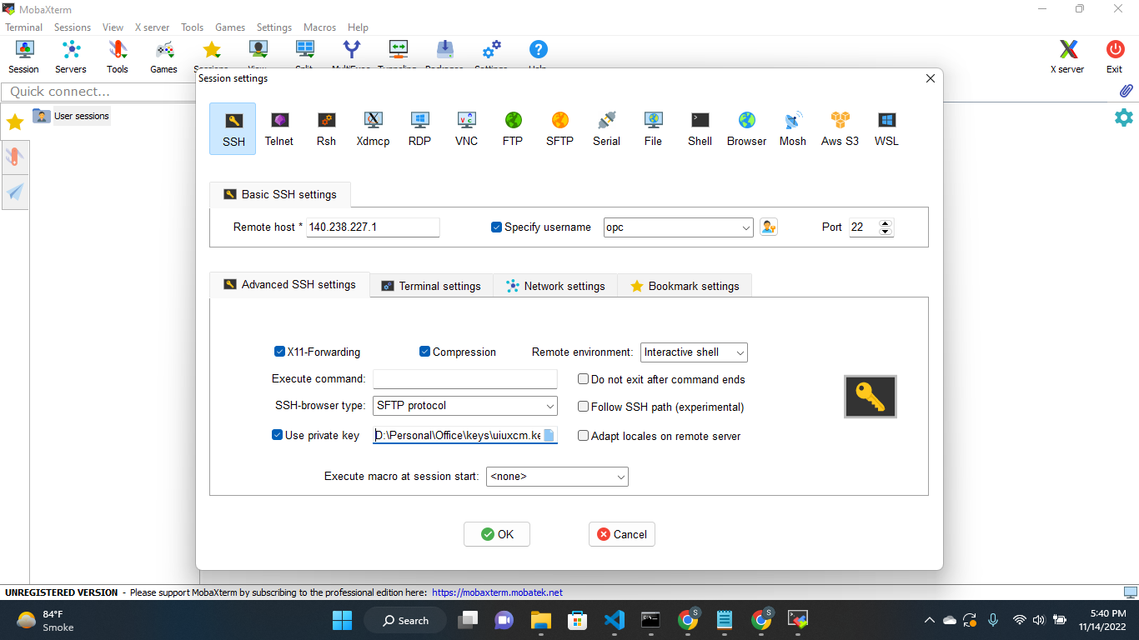

Click on Bookmark settings. Enter Session name. Click on OK.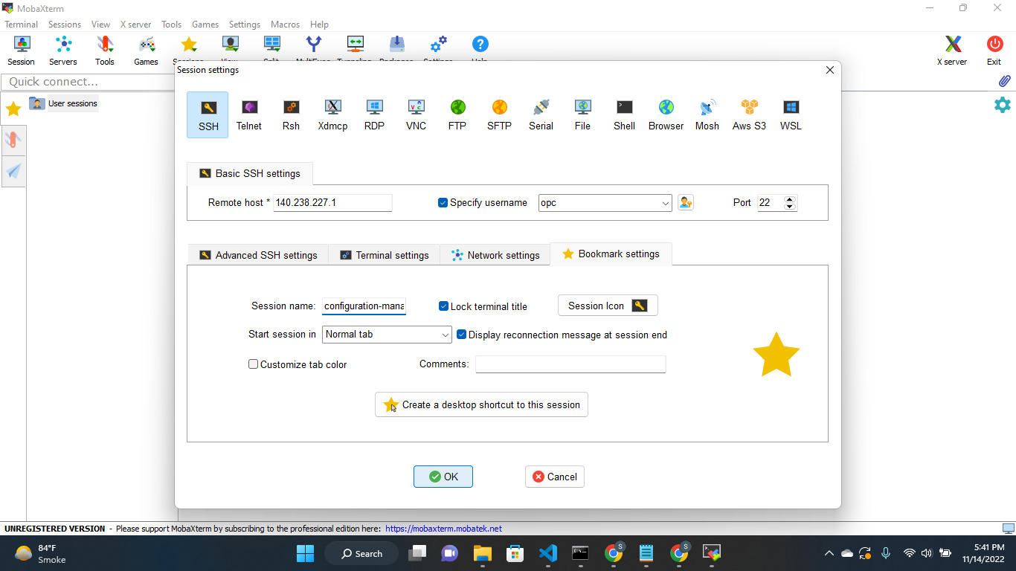

# Folder Details

Refer folder conf-migration. Open the folder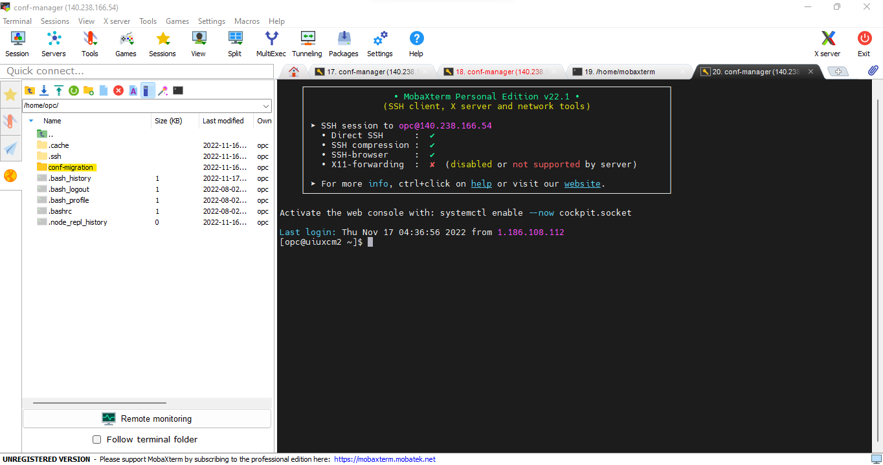

conf-mgr-service-python – Code is running on port 8001 – **NOT USED**

conf-mgr-backend – Code is running on port 3000

# Setup Python Code – Not Used

Copy (Drag and drop in) the folder from your local machine to the folder conf-migration/conf-mgr-service-python in Server machine.

In Server Machine

To run python code

> sudo su

> cd /home/opc/conf-migration/conf-mgr-service-python/Config-Migration/

> nohup python Export_task.py &

To run existing python code

> sudo su

> sudo lsof -i:8001 (copy PID)

> kill 9 <pid>

> cd /home/opc/conf-migration/conf-mgr-service-python/Config-Migration/

> nohup python Export_task.py &

To check if port is up or not

> curl <http://140.238.166.54:8001/>



OR

> ps -ef | grep python

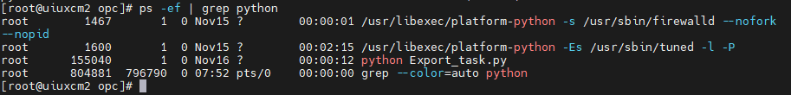

# Setup Node code

In Local Machine

In config.js file, uncomment the PROD url i.e., hostUrl

Uncomment the PROD DB password

Copy (Drag and drop in) the folder from your local machine to the folder conf-migration/conf-mgr-backend in Server machine.

In Server Machine

To run node code

> sudo su

> cd /home/opc/conf-migration/conf-mgr-backend/

> npm install

> nohup node index.js &

To run existing node code

> sudo su

> sudo lsof -i:3000 (copy PID)



> kill 9 <pid>

> cd /home/opc/conf-migration/conf-mgr-backend/

> nohup node index.js &

To check if port is up or not

> curl <http://140.238.166.54:3000/migData>



OR

> ps -ef | grep node

# Setup Angular code

In Local Machine

Copy url [http://140.238.166.54:3000](http://140.238.166.54:3000/) and paste in

conf-mgr-ui\src\environments\environment.ts file apiUrl variable

conf-mgr-ui\src\environments\environment.prod.ts file apiUrl variable

Run cmd ng build

Copy (Drag and drop in) the folder configuration-manager-ui (conf-mgr-ui/dist/configuration-manager-ui) from your local machine to the folder conf-migration/conf-mgr-ui in Server machine.

Note: In server machine, You might have to rename the folder name configuration-manager-ui which is already present in conf-migration/conf-mgr-ui

In Server Machine

To run angular code

> sudo su

> cd /home/opc/conf-migration/conf-mgr-ui/

> npm install

> nohup node index-ng.js &

To run existing angular code

> sudo su

> sudo lsof -i:4200 (copy PID)

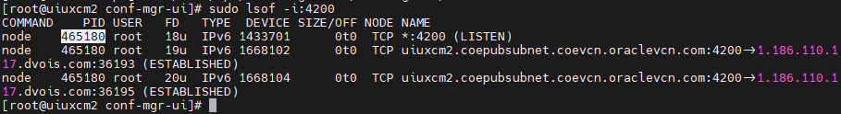

> kill 9 <pid>

> cd /home/opc/conf-migration/conf-mgr-ui/

> nohup node index-ng.js &

To check if port is up or not

> curl <http://140.238.166.54:4200/>

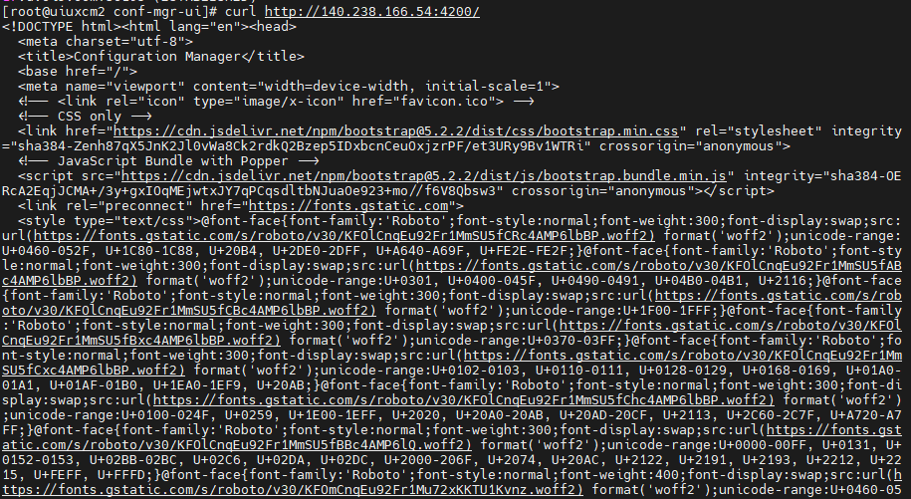

OR

> ps -ef | grep node

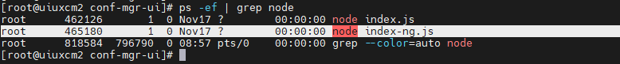

# Linux Commands

Open port using below cmd

firewall-cmd --permanent --add-port=8001/tcp

firewall-cmd --permanent --add-port=3000/tcp

firewall-cmd --permanent --add-port=4200/tcp

firewall-cmd --permanent --add-port=3306/tcp

firewall-cmd --reload

To check if port is up or not

curl http://140.238.166.54:8001/

curl http://140.238.166.54:3000/migData

curl http://140.238.166.54:4200/

To check the list of open ports

firewall-cmd --list-all

Run the code

nohup <run-cmd> &

nohup python Export_task.py &

nohup node index.js &

nohup node index-ng.js &

Check which code is running

jobs

ps -ef | grep node

ps -ef | grep python

This will give you list of active pid's on that port

sudo lsof -i:<port number>

kill 9 <pid>